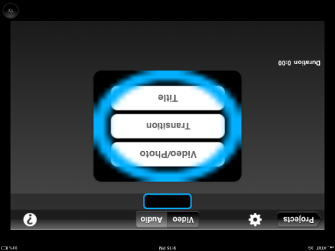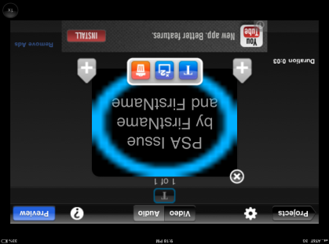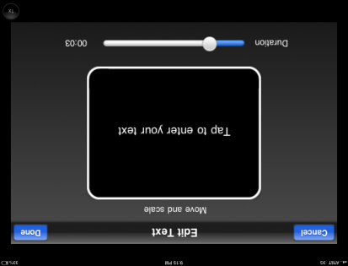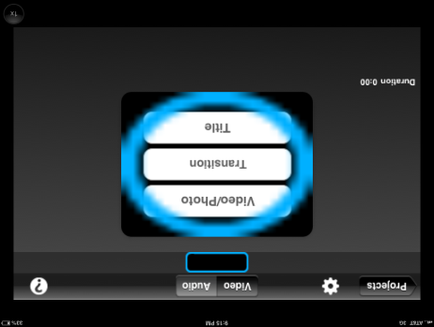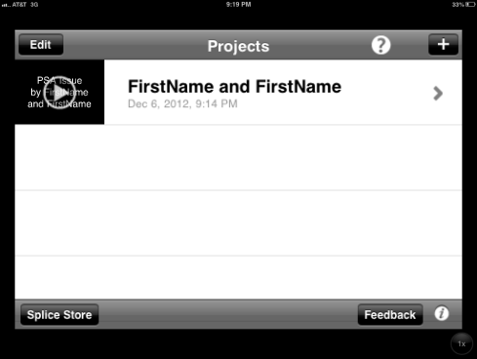

7. Edit OR Duplicate OR Delete

1. Tap to Edit

**FirstName and FirstName**

1. Name project
2. Start project
3. Add Transition or Video/Photo

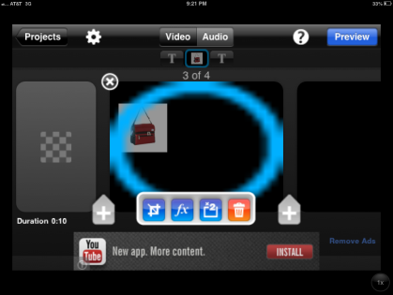

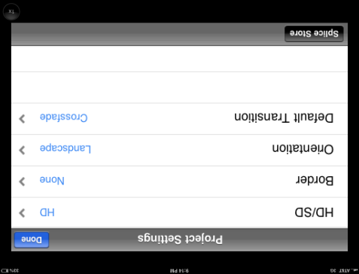

3. Pick settings

1. PHOTOS—Crop/Change Speed OR Filter OR Copy OR Trash

*(Click pencil icon to start editing)*

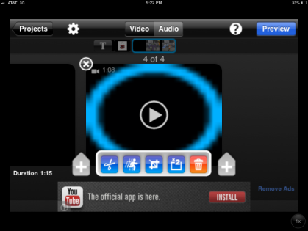

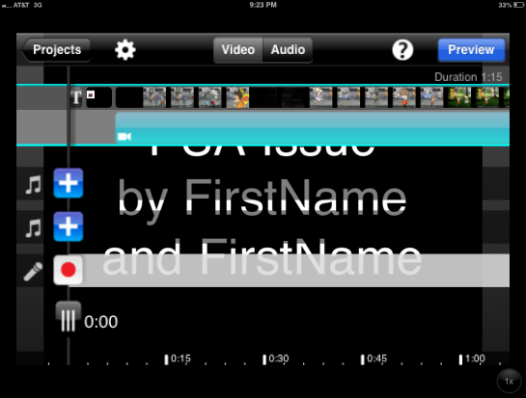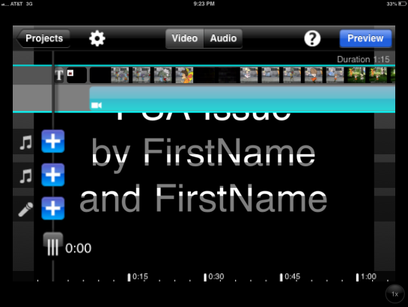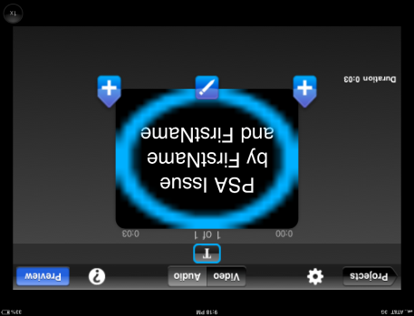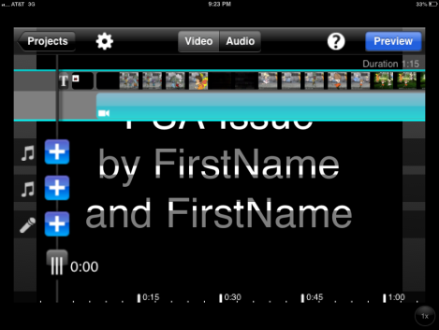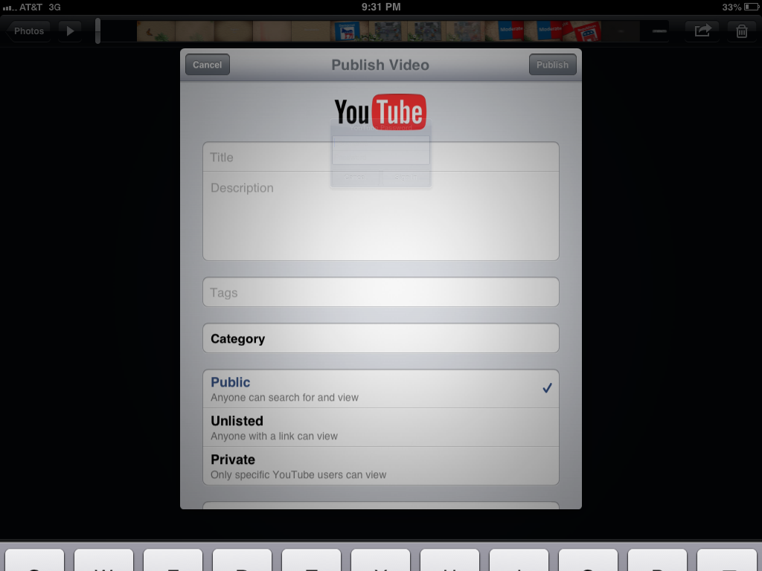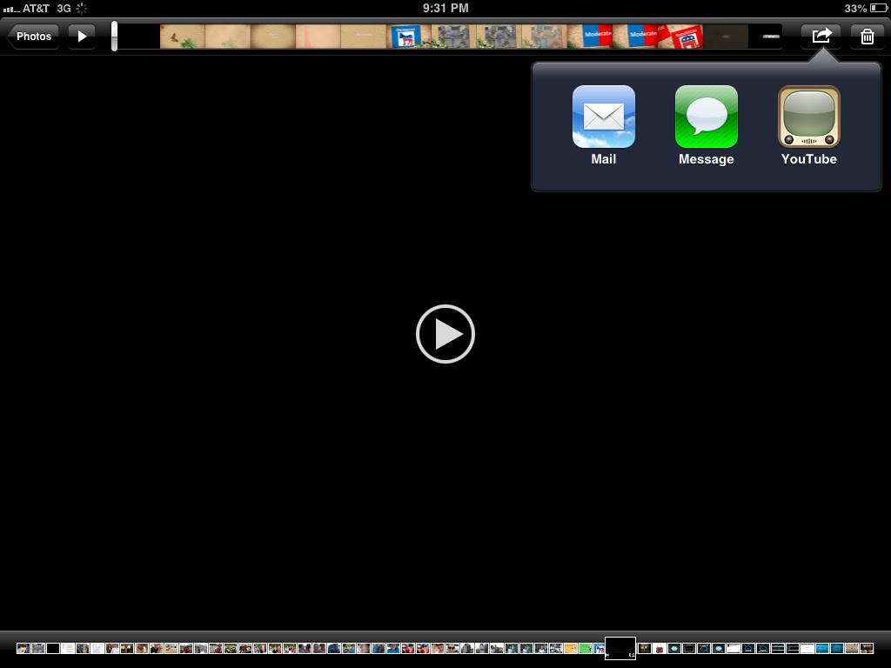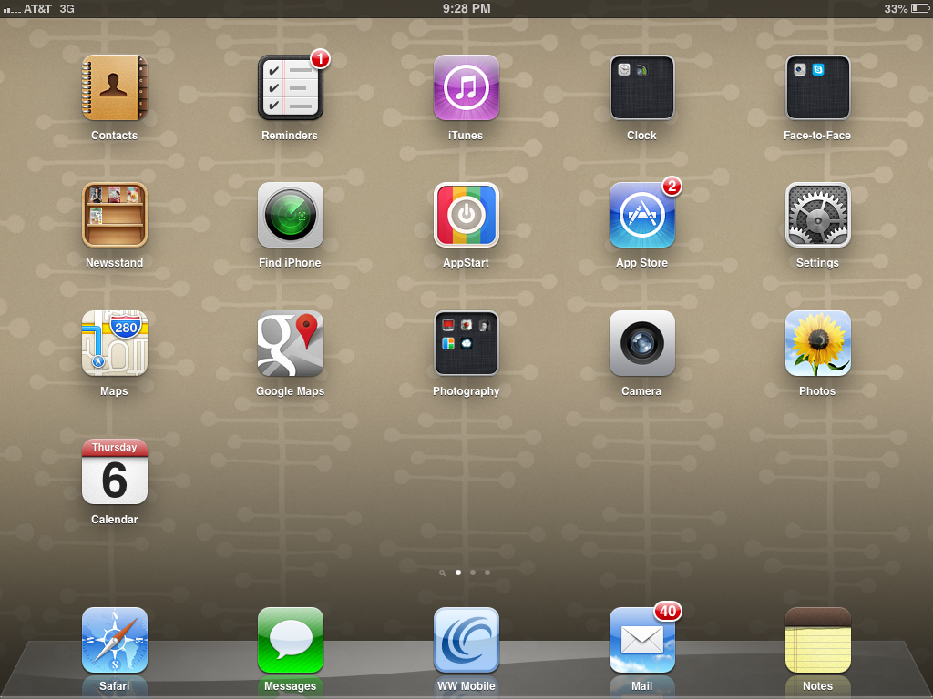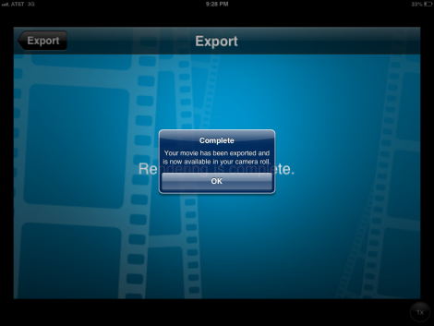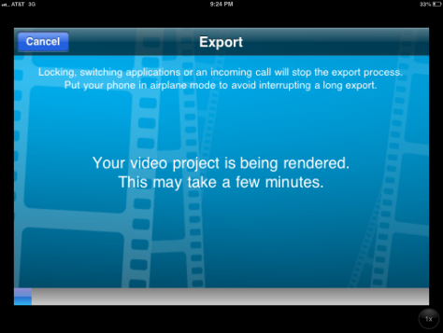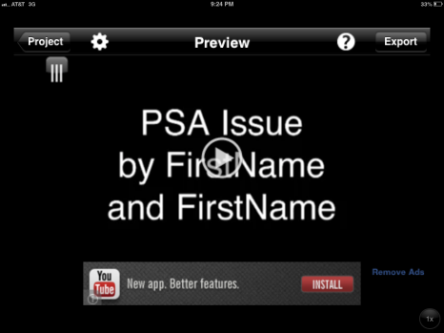

Use music note track to add music ($issue) Narrate

1. Use Slide to determine recording location
2. Tap to red dot to begin recording
3. Change speed

**ADD AUDIO ONLY WHEN ALL PICTURES/ VIDEOS/ TRANSITIONS ARE DONE!!!**

1. Tap Audio To Narrate
2. Pick Next Element

**__Topic__ by FirstName and FirstName**

1. Add Title Slide
2. VIDEOS—Cut OR Change Speed OR Crop OR Copy OR Trash
3. Preview Video (do this at any point during the process to check on your movie)

ONLY FirstName and FirstName

English 9 PSA - __TOPIC__

Education

**GET HELP FROM YOUR TEACHER TO POST TO YOUTUBE!!!**

1. Post to YouTube
2. Tap Share
3. Find completed video
4. Check Camera Roll for video
5. WAIT! Wait for export
6. Satisfied? Export