An Introduction to Global Positioning Systems (GPS)
- The basics
- A bit of history: where did GPS come from?
Sadly, as it happens with many of our technological breakthroughs GPS were initially created to wage war:
In the latter days of the cold war arms race the targeting of ICBMs became such a fine art that they could be expected to land right on an enemy's missile silos. Such a direct hit would destroy the silo and any missile in it. The ability to take out your opponent's missiles had a profound effect on the balance of power.
But you could only expect to hit a silo if you knew exactly where you were launching from. That's not hard if your missiles are on land, as most of them were in the Soviet Union. But most of the U.S. nuclear arsenal was at sea on submarines. To maintain the balance of power the U.S. had to come up with a way to allow those subs to surface and fix their exact position in a matter of minutes anywhere in the world Hello GPS!
- How does a GPS work?
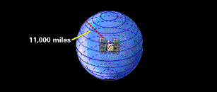
  - The Global Positioning System (GPS) is a worldwide radio-navigation system worldwide radio-navigation system formed from a constellation of satellites and their ground stations developed and maintained by the United States Department of Defense (DOD). The constellation of 24 US NAVSTAR satellites orbits the Earth twice a day at a very high altitude (The Russians and Europeans have their own now)
  - Turn on your GPS Units….what is the first thing it does?
  - The basis of GPS is "triangulation" from satellites….and what is triangulation?
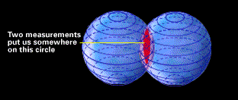
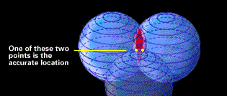
Let’s talk Algebra, physics and…geometry!!!... We're using the word "triangulation" very loosely here because it's a word most people can understand, but purists would not call what GPS does "triangulation" because no angles are involved. It's really "trilateration."
Trilateration is a method of determining the relative positions of objects using the geometry of triangles….

One satellite, Two satellites, Three Satellites
At least 3 satellites should be in view of the receiver to estimate its horizontal position (4 for including elevation).

- How do we measure the distance?

By measuring how far off we would hear music playing from a satellite, that started playing at the same time we started the same music on our radios…..UH?

In a sense, the whole thing boils down to those "velocity times travel time" math problems we do in high school.
Remember the old: "If a car goes 60 miles per hour for two hours, how far does it travel?"

Velocity (60 mph) x Time (2 hours) = Distance (120 miles)
In the case of GPS we're measuring a radio signal so the velocity is going to be the speed of light or roughly 186,000 miles per second. The problem is measuring the travel time…..
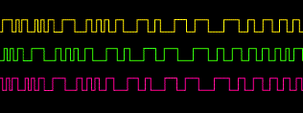
So…How we do measure time?

How long does it take us to sound like we are singing together???....

The time it takes allows us to estimate the distance.
Now we are talking speed of light here!!!

If measuring the travel time of a radio signal is the key to GPS, then our stop watches had better be darn good, because if their timing is off by just a thousandth of a second, at the speed of light, that translates into almost 200 miles of error!

So we bring a 4th satellite for just in case!... Or more! If our receiver's clocks were perfect, then all our satellite ranges would intersect at a single point (which is our position). But with imperfect clocks, a fourth measurement, done as a cross-check, will NOT intersect with the first three.

Some extra care…

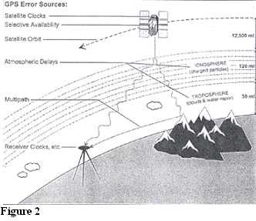
Sources of Error in GPS
GPS signals travel in varying speeds depending on the medium through which they pass. The signals can be delayed as they move through the charged particles of the ionosphere and the water vapor of the troposphere. These delays cause errors in calculating distance, thus affecting the GPS position as shown in Figure 2. The satellites themselves cause other GPS errors because their atomic clocks may be slightly inaccurate or they may drift from their orbit. At the ground, errors can be caused by the receiver’s inaccurate clock and the effect of mulitpath.
Multipath error is the interference caused by some of the signals bouncing off local obstructions, such as tall buildings and being delayed in reaching the receiver.

Differential GPS
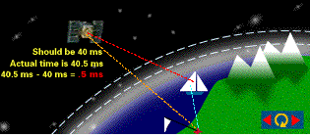

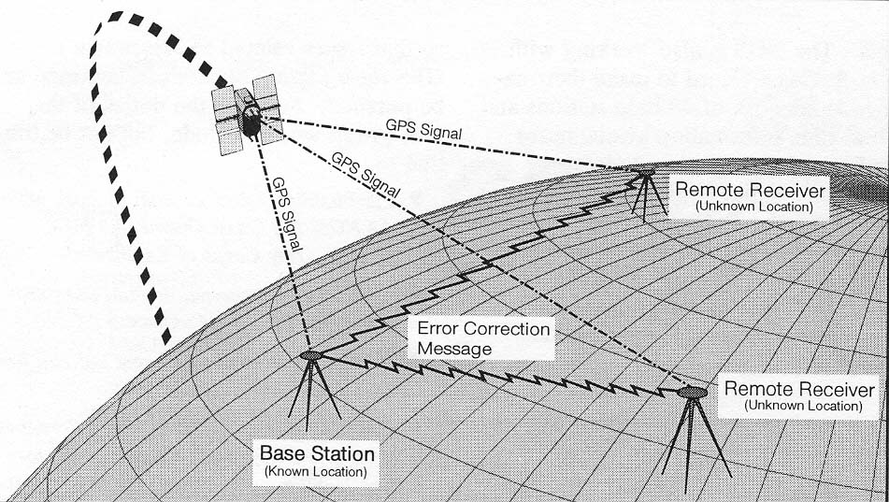

DGPS improves the point positioning accuracy to just a few meters of error (3-10m or better). It requires at least two receivers, a base station, and rover. The base station is a point of known X, Y, and Z location that receives signals, and transmits corrections. A rover is any mobile GPS receiver which receives signals from same satellites and corrections from a base station. So essentially DGPS significantly reduces all the sources of error previously discussed, except ground receiver and multi-path errors. Receiver errors are reduced by equipment design while multi-path is controlled by site selection.

- Let’s play with a GPS.

- The coordinate system we will be using: UTM

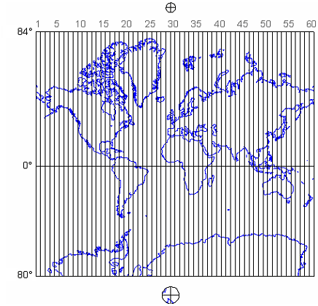

Why does it take time to a GPS to get a stable reading?
If we know that the coordinates are what is our margin of error?
How does it know how fast you are going?

Hunt the treasure…Bury the treasure and bring the data to Google Earth

An Introduction to the world of Geographic Information Systems (GIS)

The purpose of this exercise is to introduce you, in a practical way, to some of the fundamental concepts and functions of GIS. You will also come to realize how GIS is currently present in some of the most common things we do on a daily basis.

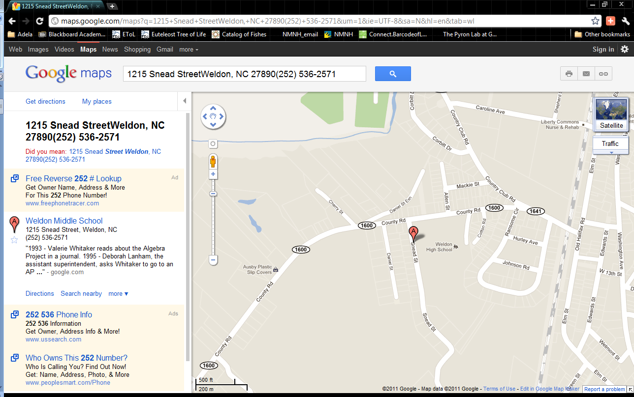
- Google maps
- Start your web browser.
- Go to www.google.com
- Click in the Maps link.
- Search Weldon’s middle school
- “Weldon NC Middle School”

- Look carefully at the map that is being displayed. I am sure you have seen these many times but perhaps never asked yourself how this is done. We talked in the introduction about the two main types of data used in a GIS: raster and vector data.
- Mention the type of data format data that are being displayed and what they represent, mention 2 of the attributes that are being displayed ______________________________________________________________________

How do you think Google Maps was able to locate UNCW’s address in the map?

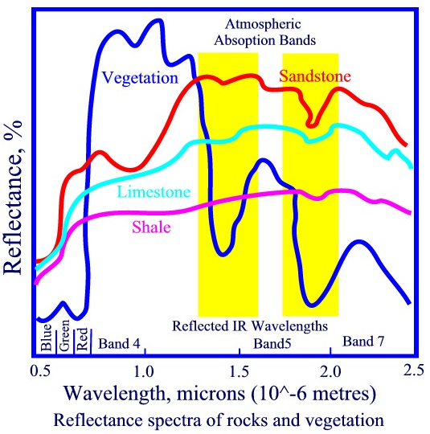
- Click on the Satellite tab. Mention the type of data format data that you think are being displayed __________. Why? __________ __________________________________________________
We explained in the intro most of the data we use in this format is acquired by means of Remote sensing (measuring the light [electromagnetic energy] that the surface of the earth reflects back to a sensor and then analyzing how the energy reflected it the result of interactions with what is in each place).
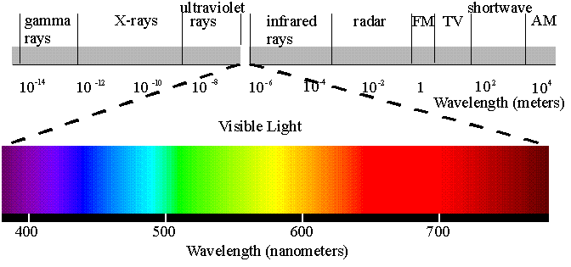

This is an Aerial Photography from the National Agriculture Imagery Program (NAIP) from the USDA. These are acquired every 3 years. Each pixel (like in your digital cameras) can cover around 1 square meter (around 9 sqft) on the ground. For more information visit http://www.apfo.usda.gov/FSA/apfoapp?area=home&subject=prog&topic=nai

- Click on the Address bubble. Select the “Directions” link located inside the window that pops up. This tool will help you obtain driving directions from Weldon’s Middle School to your place (as you probably have done many times). Put your home town as your destination for Google to obtain the directions. Now here comes the novelty. How can Google maps do this?
- Mention the types of information you would need in order to be able to put together a map like this with all the information you are being provided in the results (Route, Distance, time depending on means of transportation).
- Mention three attributes the roads layer Google Maps uses need to be have available for each road segment (related with the layer) in order to be able to establish: which roads to use, the total distance and the estimated time (use your imagination).
- Which areas of knowledge that you teach are required to be able to do this? What for?
Now go to the Show options link on the left below the box where you put the addresses and select Avoid highways. Then Click on “Get Directions”. What happened? What information do you need about the roads to do this?
Do the same adding “Avoid tolls”. What data do you need to be able to do this?

- Using Google maps for conservation: MOABI.

Accelerated global warming due to high rates of emissions of Green House Gases is a fact. Even though global warming can be a natural process, the rate at which it is currently occurring precludes any possibility of the ecosystems of the earth to adapt to a gradual change. Smoke stags from coal fired power plants are the biggest emitters of GHG. However these are followed by a well know source (Cars) and believe it or not, Tropical Forests Deforestation. How come? You can watch a short video here. http://www.conservation.org/learn/climate/solutions/mitigation/Pages/climate_REDD.aspx.
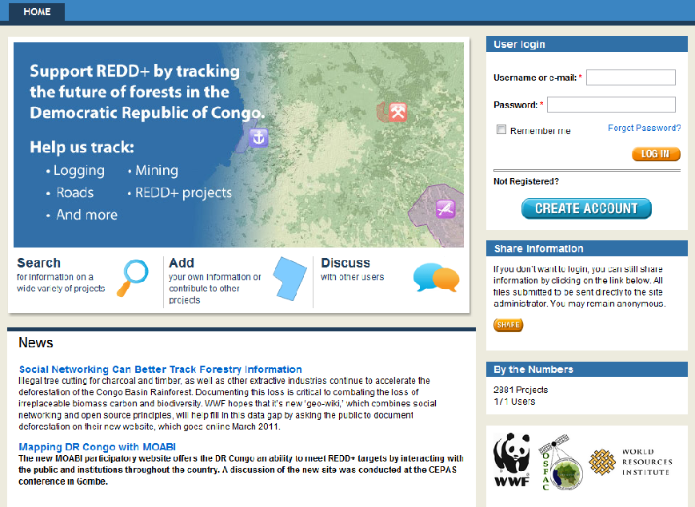
In order to revert this problem, a program seeking to preserve forest cover, the biodiversity within them and the people living there also: Reduction of Emissions from Deforestation and Forest Degradation (REDD+).
In order for this program to succeed we need to keep a close watch to our forests and to those things that can cause forest cover loss, such as the creation of new highways, Dams, etc.
Within WWF we have been working developing a tool that with Google maps and with characteristics of a social network such as facebook or soon as Google Plus can help us keep tract of deforestation as well as of potential threats, all in a transparent way. Such is the purpose of our recently launched MOABI tool.
Please go to http://rdc.moabi.org/
Login using Username: mosbi.demo
Pw: mdemo5

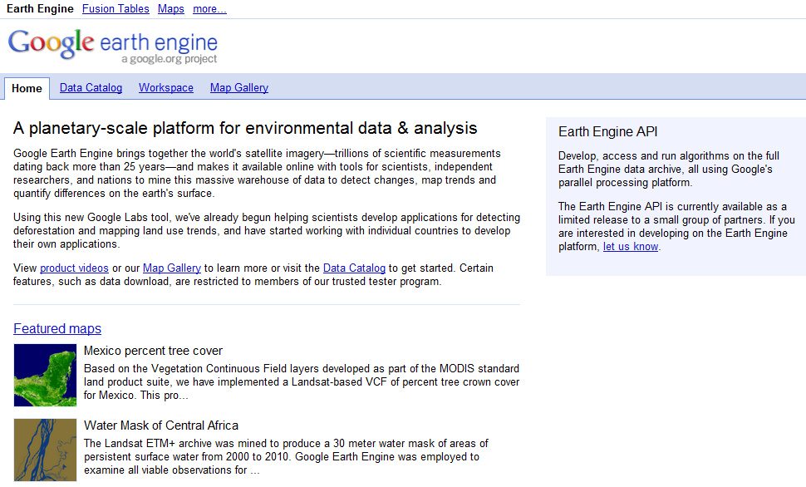
- Earth Engine An interactive way for scientists and decision maker to share geospatial data relevant for natural resources sustainable management
- In your web browser go to http://earthengine.googlelabs.com/#intro. Read the general introduction.
- Follow the “Featured maps” Link. This activates a link between Google and Google Earth.
The featured maps allow you to explore different datasets that have been made available by different scientists on the platform provided by Google Earth.
- Select any of the featured maps. You will see how the map is displayed on the Google Earth map and a short description of the data allows you to understand what you are looking at.
- Choose the Democratic Republic of the Congo Forest Cover Loss, 2000 to 2010
Potapov, P., et al Provisional map of forest cover change in the DRC from 2000 to 2010.
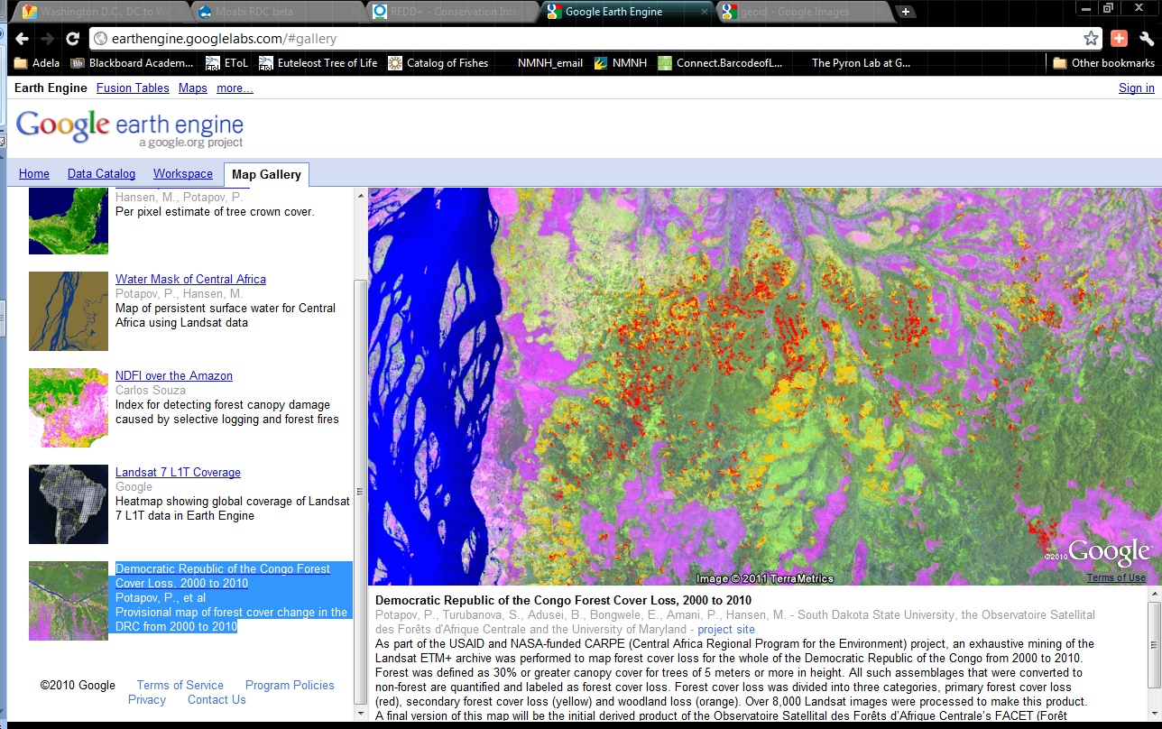

This map depicts the deforestation occurred in the Democratic Republic of Congo between 2000 and 2010 as detected with satellite imagery (the orange and red areas). The data are being used to predict which areas are at most risks of being deforested and therefore prioritized for the implementation of mitigation actions like those proposed by REDD+
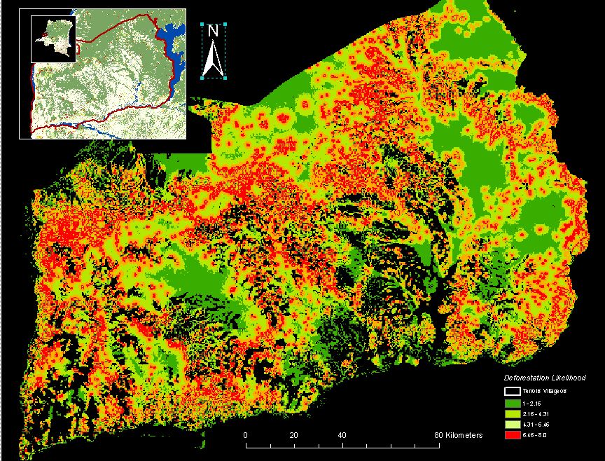

- Go to the Data catalog Link.
- Scroll down and select the” Landsat 5 32 day EVI Composite”. This is a Landsat 5 data derived map that depicts vegetation greenness. Select the link. That says “open in workspace”.
- See that now you are in the Workspace tab. Zoom into an area of your choice by double clicking several times.
- See that a “loading maps” sign shows up…be patient
- Also see the on the left side you have a date bar. If you play with it, you will see the greenness changes according to the dates. Why??? What do you think this could be useful for? Let’s say you are in a tropical forest area and suddenly the greenness goes drastically down from one map to the other….what happened?

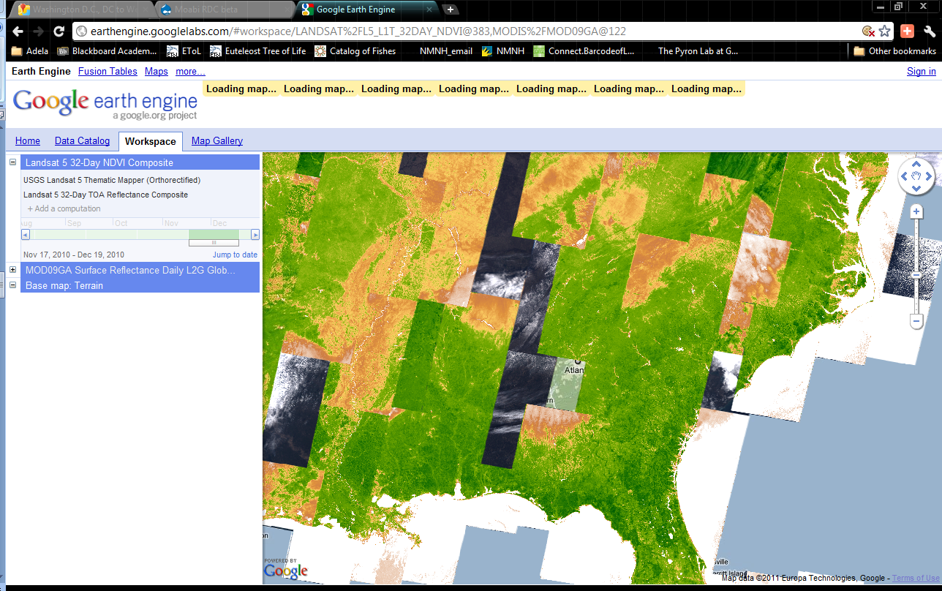

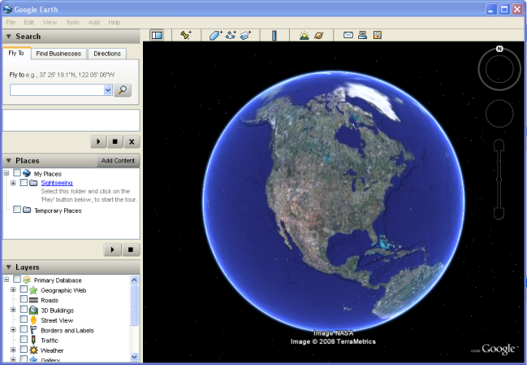
- Google Earth.

In this part of the exercise we will play with one of Google’s gadgets: Google Earth. You can download Google Earth for free (the free version that we are using) at http://earth.google.com/ . You may have already used Google Earth before for figuring out the location of interesting places around the globe or even to check on if you can see the roof of your house using it. Well, Google Earth is an excellent example of a general data use/display/query Geographic Information System. It represents an excellent example of what a GIS user interface should be. We are now going to use Google Earth to enhance our understanding of some key concepts and capabilities of a well oiled GIS.

- Start Google Earth.
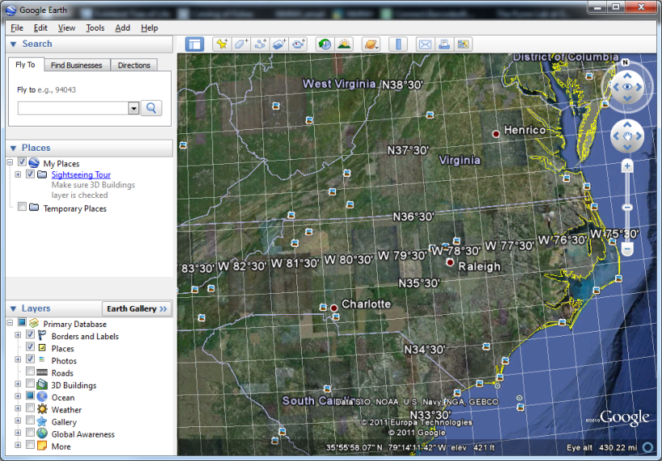
- Once it is opened, close the tip window.
- Zoom into any location you like. You can do this just by double left-clicking on it (if you right-click, you will zoom out).

What you are looking at is a mosaic of satellite images (a collage of the best images available for each location that work at the zoom level you are looking at). Not all the images were acquired the same date or even the same year. However, Google tries to put the most recent ones that have the least cloud cover (always a problem when using satellite images). You can see this as the texture is not even. Some images are darker than others and so on. Furthermore, some images were acquired during different seasons: Those acquired in during the leaf off season look browner than those acquired during the growing season (greener ones).

In order to be able to put together all these images in such a nice way, what basic conditions do these images need so Google’s GIS system could know which one would go next to the other?

- Now, zoom out back to the original extent (right click as many times as you need).
- Go to the top menu bar, open the View Menu and click on “Grid”.
What type of grid shows up? _______________________________________________

- Ho do latitude and Longitude work? ……..It’s all geometry!!

First, the shape of the Earth…
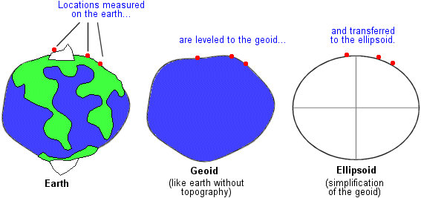
Latest one: WGS1984

Second, the coordinate system…
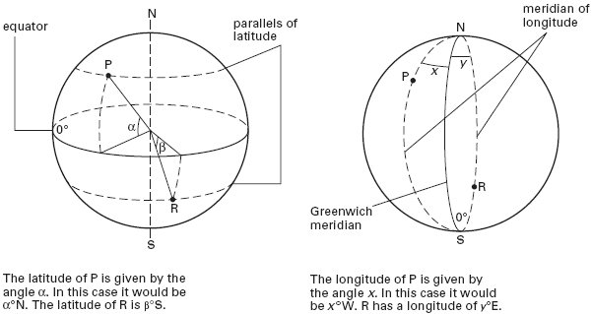

- In the Fly to window, put Weldon’s Middle School address: 1215 Snead Street, Weldon, NC 27890. See how the image refreshes itself as you zoom in. This is because the system goes through displaying different types of satellite imagery until it finds out the right one for the level of zoom (map scale you are in).
- Zoom in to the running track south the school building. 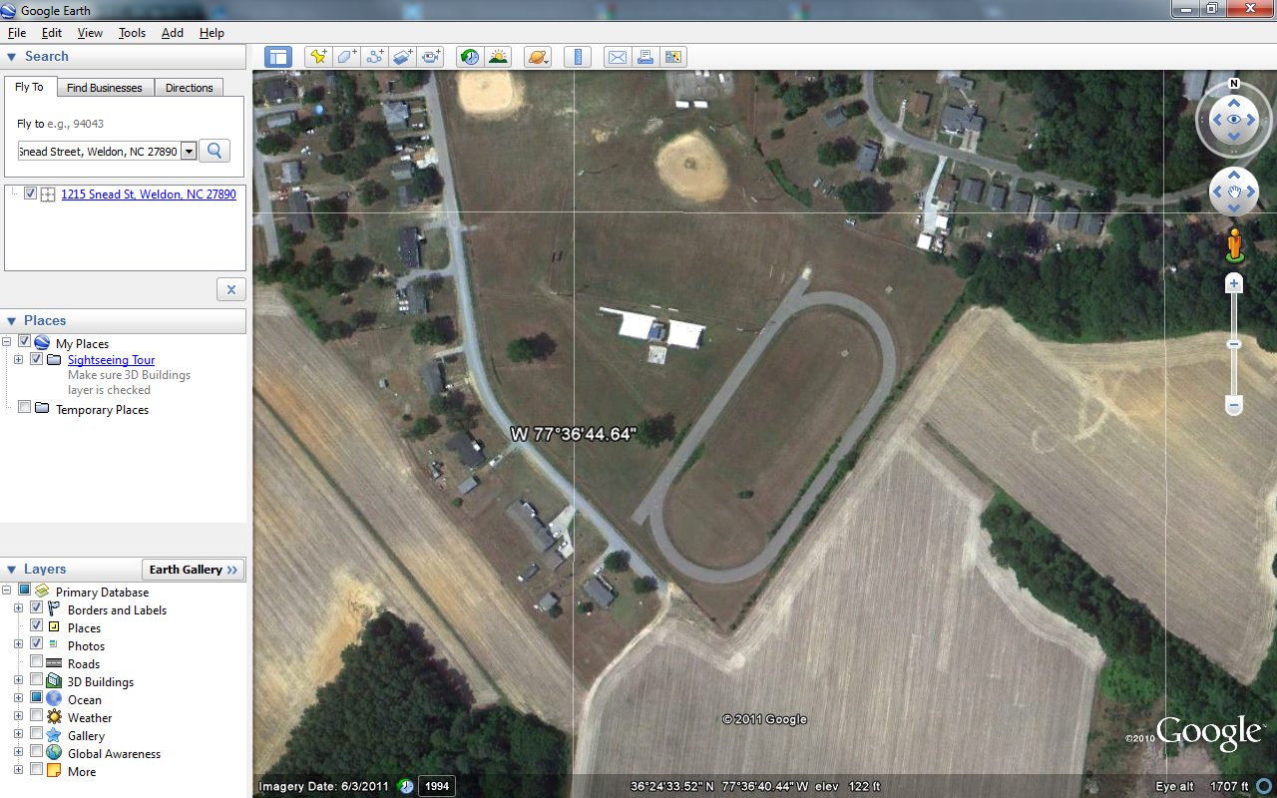

What are the exact coordinates of the northwest corner of the northern end of the straight portion of the track? What is the elevation of this point? _______ See that the coordinates are displayed at the bottom of the screen and change as you move the mouse over the mapping area. N____________________________ W____________________________

- Now, go back and turn the grid off. In the same View menu tab activate the “scale bar”.
Can you estimate the distance of the straight of the race track? _____ Feet.
- Now go to Tools/Ruler and use the tool to measure the actual distance
(Remember to select feet as the length option).____________feet.

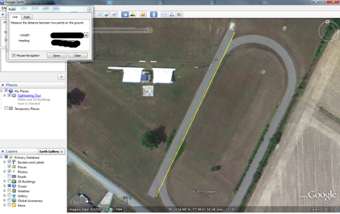
- Was this track here in 1994? At the bottom left corner of the map you will see am Imagery date: 6/3/2001. This is the date this photo was acquired…fairly recently… Click on the 1994 next to this date. What happens?

- Now, my mistake. …Weldon NC Middle School is not the same as Weldon Middle School
The address is actually 4489 HMY 301 Halifax NC.

Do you think Google did a good job?
Why is this happening?

Can we solve this problem?
Let’s use our GPS data! Importing the data from your GPS device to Google Earth is simple:
- Connect your GPS device to the computer running Google Earth with the serial cable or USB cable that came with your device. Make sure your GPS is turned off when connecting.
- Turn on the GPS device. Once your device is on and activated, it is not necessary to wait until it connects to satellites.
- From the 'Tools' menu, select GPS. The “GPS Import” window appears.
- Under Device, select the correct manufacturer type for your GPS device. If you are importing a file, select “Import from file.” For more information, see Importing Existing GPS Data Files.
- Under Import, select the types of data you want to import. We recommend using the default option to have all three types selected. This will allow for all types of GPS data to be transferred.
- Under Output, select KML Tracks" or “KML LineStrings to choose how you would like your GPS tracks to be displayed. Learn more about KML Tracks and KML LineStrings.
- Check the Adjust altitude to ground height option to adjust all recorded points to ground level, such as when importing a track taken on foot, car, or bike. However, if your GPS track was recorded while traveling by air, such as hang gliding or flying on a plane, make sure this option is not selected so that your points appear as above-ground points.
- Click Import. When your GPS data is finished loading into Google Earth, a confirmation dialog box appears.
Your data appears in the Places panel with the label GPS Device. If you expand the GPS Device folder, you can see your GPS data sorted into separate folders depending upon the type of data, as illustrated in the example below.
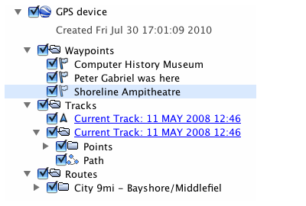
Now we have incorporated some of our field work data into our GIS….

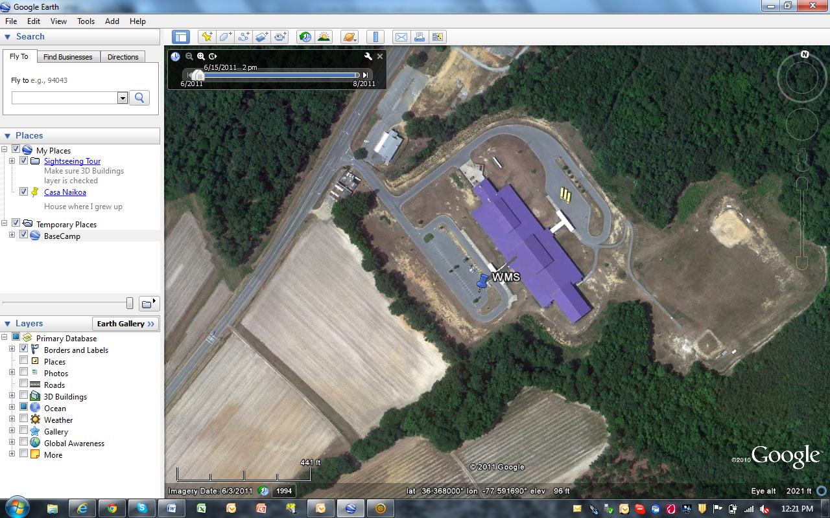

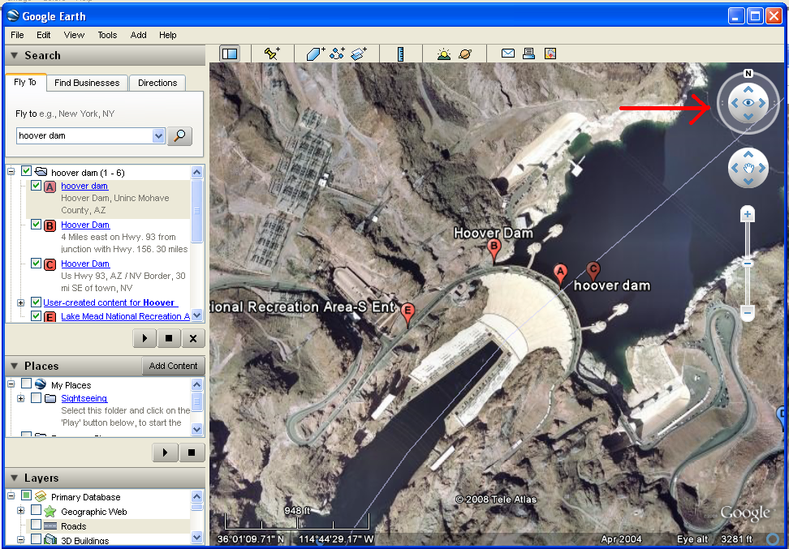
- Now, using the Fly To window, fly to “Hoover Dam, Uninc Mohave County, AZ”.
There is an eye with 4 arrows on top right side of your screen. Click on the top one so your view angle gets lower. Use the hand shaped cursor to keep the dam on sight. You can also rotate the view direction by clicking on the N symbol next to the eye, and Zoom in and out with the other set of arrows below the first one. Once you are satisfied with the sight, activate the Terrain Layer on the left side layer list (It is the very last one in the bottom of the list). Reset your sight so you can have a nice view. Zoom in and out, move your sight around. Have fun!

What types of data sets were required in order to generate this view option? (There is a fundamental one)

Finally, go to Tools/Enter Flight Simulator. Select your plane and try to flight the Grand Canyon!

