about I resources I shared I search I donate I contact

Modelling sea level change on the Gold Coast

Introduction:
Surfing is a hugely popular activity, driven by a multi-billion dollar industry. Climate change, and the possibility of rising sea levels, could have a drastic affect on the sport.
Duranbah, Gold Coast, Queensland, Australia
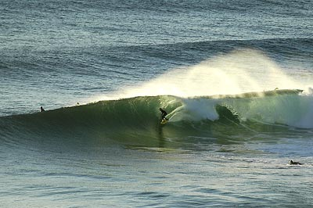
Source of image I copyright Flickr user JonasPhoto

This lesson uses Google Earth to investigate the impact of sea level change on the Gold Coast, Queensland, Australia.
The Gold Coast
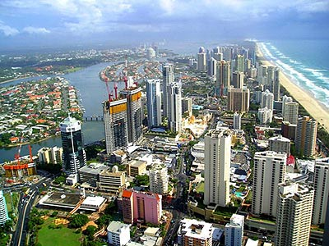
source Wikipedia

The Gold Coast is the most popular location for tourism in Queensland; one of the biggest draws being the internationally renowned surfing beaches.

Gold Coast Surf
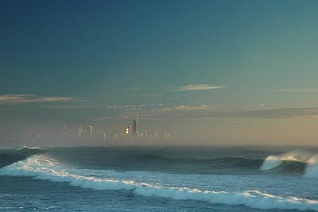
Source of image I copyright Flickr user JonasPhoto

Aim:
The aim of the lesson is to create a series of Google Earth polygons to illustrate the impact of sea level change. These form the basis for a report style assignment. Click to enlarge the thumbnail below:
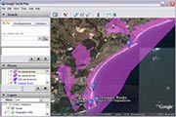

Credits:
The lesson uses images kindly made available by Flickr users Jonas Photo, TigglesofOz, yaruman5, and beppovox under a Creative Commons license. The technique for creating polygons to represent sea level change is also described at Lightblueline.

Resources:
I recommend that the following files are downloaded, opened in Google Earth and checked beforehand:
Google Earth placemark: Gold Coast overview
Google Earth placemark folder: Surfing locations
Google Earth polygon folder: Sea level change polygons (optional)
All files

Learning Activities:

Starter activity:
Zoom in to Snapper Rocks to note the surfers in the water
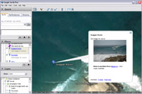
Open the folder of placemarks illustrating some of the other surfing locations. Discuss why the location is so important to the surfing community.

Main Activities
(1) Describe the physical and human features of the region
Open the Gold Coast overview and investigate more closely in Google Earth
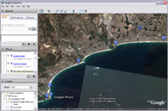
(2) Check the live webcams: Surfers Paradise & Duranbah
[other cams]
(3) Draw a sketch of the Gold Coast region, based on the overview placemark.
Use information from the Layers Panel to annotate it. The most useful information from the panel can be found under "Geographic Web" as shown below. Other information can be turned off.
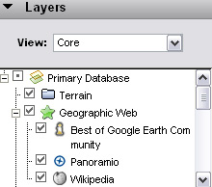
(4) Create a series of polygons to represent sea level change, or use the polygons here.
• Zoom to the desired level and turn on Terrain via the Layers panel
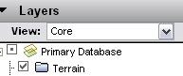
• Choose Add Polygon from the top menu
• Use the mouse to click and drag nodes to create the polygon over the desired area. The polygon appears white and the dialogue box appears:
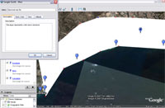
• In the dialogue box name the polygon and add a description if desired.
Under Style, change the colour (reds and purples work well) and set the opacity to between 50 and 60%.
Under View click snapshot current view:
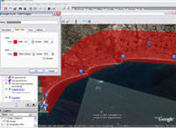
• Under Altitude, move the slider to the desired sealevel height (e.g. 5m)
Select Relative To Ground and then click OK to exit the dialogue. Create polygons to represent 1 5 and 10m sea level rises:
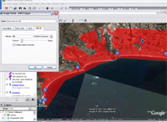
(5) Draw another sketch of the coastline to show how sea level change could affect the Gold Coast.
(6) Assignment
Write a report or produce a presentation to describe the impact of a 1m 5m and 10m rise in sea level on the region. Use screenshots from Google Earth to illustrate the report.
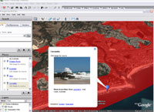

Plenary
Students could discuss whether it is feasible to protect the Gold Coast from sea level rise with engineering solutions. There are several examples of large scale coastal management engineering projects in the area including the Narrowneck Reef and the Tweed Sand Bypass Project.
Coastal engineering placemarks

