**08/2012**

**GIS, Climate Change, REDD+, Carbon Emissions Estimates…**

***The REDD Planet***

**Introduction:**

This exercise will make you aware of a global environmental problem you might not be aware off: The relation between **Tropical Forests** **Loss** relation with **Global Warming** and of some of the efforts international community is currently trying to make to deal with it.

The object of this activity is for students to think about a real issue in our world and use mathematics to help understand it. Carbon Dioxide in our atmosphere is causing many problems.

***In this practice you will use the internet, GIS systems, physics, mathematics, biology and chemistry knowledge you teach your students to discover how to track tropical deforestation and estimate CO2 emissions resulting from it.***

1. **Specific Objectives**
2. Build environmental awareness
3. Demonstrate linkages between Biology and Chemistry
   1. Biomass, and carbon in trees
4. Demonstrate linkages Chemistry and mathematics
   1. Carbon and emissions estimates
5. Demonstrate linkages between mathematics and physics
   1. Carbon storage in trees
6. Demonstrate linkages between Science and real life problematic in a fun way.
   1. GIS, Remote Sensing and carbon emissions
7. **REDD+**
8. What is REDD? Let’s watch a short video!

<http://www.youtube.com/watch?v=4Z4TIC1ObUI>

1. **How do we Measure Emissions coming from Tropical deforestation?**
   1. The need of a **Forest Monitoring System**…How?
   2. Where are the forests? Analysis of satellite data

***Let’s have a look at The island of Borneo, home of the orangutan:***

**An Online Geographic Information’s System:**

<http://www.wri.org/media/maps/forest-cover-monitoring/>

1. Read the intro
2. Where are the forests?
   * Zoom in!
   * Classifying the satellites images to make a map:
     1. Uncheck the Change box.
     2. Check the More Maps box
     3. 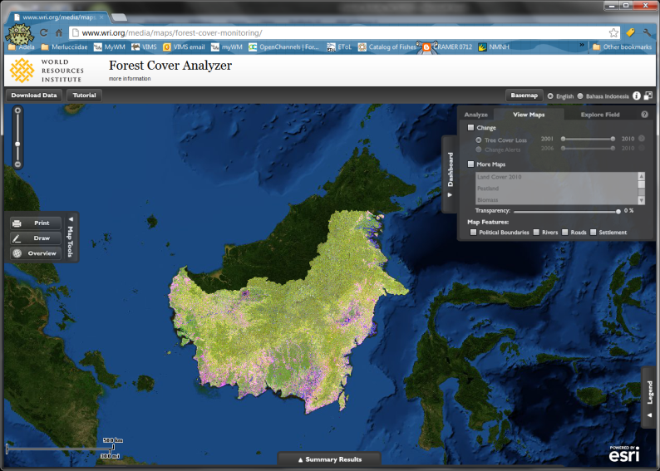Select the LandCover 2010 map
     4. Look at the legend!

**This island used to be all tropical forests.**

* **What happened to them?**
* **Where are most of the remaining forest forests?**
* Uncheck More Maps
* Go to Basemap
* Select Topo

**What can you tell about where is deforestation happening?**

* Go back to Satellite
* Check More Maps again and select: Intact Forest 2000

**Let’s have a look at the changes occurred between 2000-2010.**

* Check the Change Box
* Select Tree Cover loss 2001-2010: Move the bar!!!!!
* **UnCheck** More Maps again and select: Intact Forest 2000

**What can you tell about where is deforestation happening?**

* + Select the Analyze tab
  + Select More Areas of Interest
    1. Who is to blame? Select alternatively:
       1. Logging Concessions?
       2. Timber concessions?
       3. Oil palm concessions?
       4. **Click on an Oil concession**
       5. **Click on Detail Results and have a look at them**
  + **UnSelect** More Areas of Interest

Create your own Area of Interest:

* + **Select My Area of Interest.**
  + Select **Draw**
    1. Draw your area
       1. Circle, Rectangle, Polygon?
       2. Wait while system runs the statistics of your area of interest
  + **Click on your Area of Interest**
  + **Click on Detail Results and have a look at them**
  + **Export your table to your Desktop**
  + **Open the file with Excel**
    1. How many football fields were lost per year (2001-2010)?

**NOTE**: (1 Hectare= 2.47 acres; 1 F. Field= 1.1 acres; 1 Hectare= 2.25 F. Fields (rounded) or 1 F. Field= .45 Hectare (rounded)

How do we move from area lost to CO2 emissions?

1. Area to Biomass

The average biomass in a ha…..Then….

* + Biomass x 0.5 = Carbon
  + **Carbon to CO2?..............Chemistry!!!**

A molecule of CO 2 has 16 grams x 2 grams of O and 12 grams of C so how do we go from C to CO2???

1. How do we estimate Biomass in large areas??? **Geometry! Physics And Mathematics!....**

Trees are shapes like cylinders…well sort of…

1. 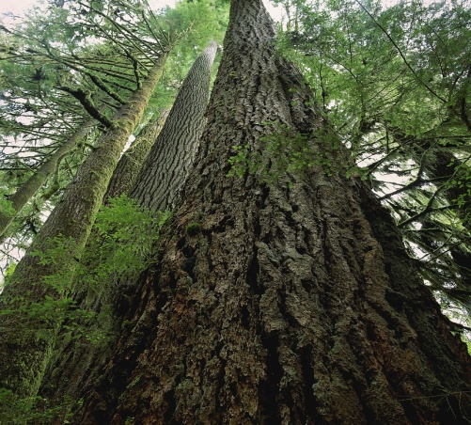A cylinder is a volume figure having two congruent circular bases that are parallel. If *L* is the length of a cylinder, and *r* is the radius of one of the bases of a cylinder, then

V= *L* × *π* × *r*2

However measuring volumes from space is very hard….we cannot measure diameters….but heights…..yes!

**We use Physics!!!.....................Light Detection and Ranging (LiDAR) technology**

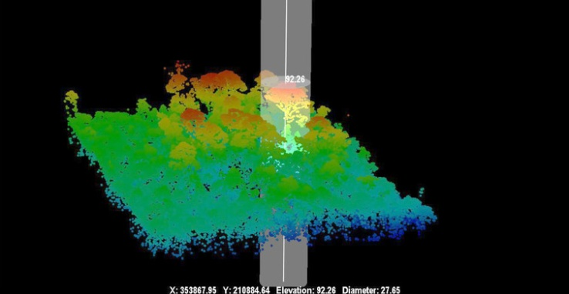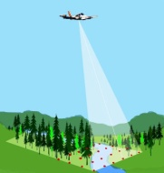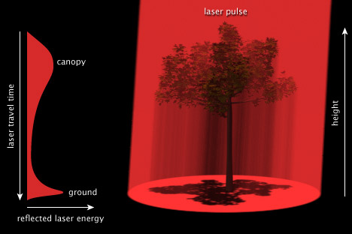

So we have an average heights estimates dataset.

* **Open the Tree_Heights Excel file we provided you…… These are data gathered from an area of forest lost in Kalimantan last year!!!**
* Actually, those are no heights!!!!!
  + **We have average times between LiDAR bounces per hectare!**
  + How do we get the average heights???? **Physics!!!!!!**
* **This type of data allows us to map tree heights across the world!**

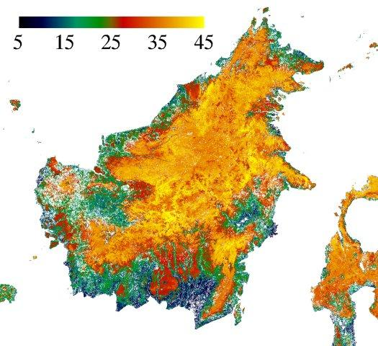

* **We have the heights….we are still missing the diameters for volume estimates….right?**
* **Then we need the densities of the wood to estimate biomass right**

Well, these relations have to be established based on field data (actually doing the work). This means cutting down the trees to weight them! This would defeat the purpose of REDD+ Right???

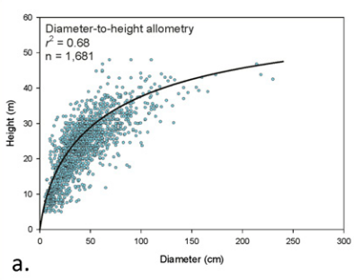Well, we cut some corners and use the relation between height and diameter (**see figure a.**). and **a relation empirically established between *average LiDAR derived height estimates and Biomass:***

*C = 0.2804(h1.8719)*

*Where C = Carbon estimate*

*h =LiDAR based average canopy height.*

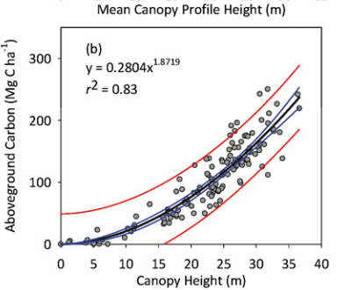

Map of forest canopy heights estimates for Borneo

* **Let’s use this formula to estimate the biomass lost!**
* **Let’s Estimate the Carbon lost!**
* **Let’s estimate the CO2 Emmitted???**

**Chemistry’s turn!**

**1 molecule of CO2 has one Carbon (12 grams) and 32 (16x2) grams of Oxygen.**

**We know how much carbon we lost….how much CO2 was emitted?????**

**Additional Background Facts about** **Carbon Sequestration:**

* Heat from Earth is trapped in the atmosphere due to high levels of carbon dioxide (CO2) and other heat-trapping gases that prohibit it from releasing heat into space -- creating a phenomenon known as the "greenhouse effect." Trees remove (sequester) CO2 from the atmosphere during photosynthesis to form carbohydrates that are used in plant structure/function and return oxygen back to the atmosphere as a byproduct. About half of the greenhouse effect is caused by CO2. Trees therefore act as a carbon sink by removing the carbon and storing it as cellulose in their trunk, branches, leaves and roots while releasing oxygen back into the air.
* Approximately 800 million tons of carbon are stored in U.S. urban forests
* A single mature tree can absorb carbon dioxide at a rate of 48 lbs./year and release enough oxygen back into the atmosphere to support 2 human beings.
* Each person in the U.S. generates approximately 2.3 tons of CO2 each year. A healthy tree stores about 13 pounds of carbon annually -- or 2.6 tons per acre each year. An acre of trees absorbs enough CO2 over one year to equal the amount produced by driving a car 26,000 miles. An estimate of carbon emitted per vehicle mile is between 0.88 lb. CO2/mi. – 1.06 lb. CO2/mi. (Nowak, 1993). Thus, a car driven 26,000 miles will emit between 22,880 lbs CO2 and 27,647 lbs. CO2. Thus, one acre of tree cover in Brooklyn can compensate for automobile fuel use equivalent to driving a car between 7,200 and 8,700 miles.
* If every American family planted just one tree, the amount of CO2 in the atmosphere would be reduced by one billion lbs annually. This is almost 5% of the amount that human activity pumps into the atmosphere each year.
* The U.S. Forest Service estimates that all the forests in the United States combined sequestered a net of approximately 309 million tons of carbon per year from 1952 to 1992, offsetting approximately 25% of U.S. human-caused emissions of carbon during that period. (Taken from <http://www.coloradotrees.org/benefits.htm#carbon> )