
In this resource, you will explore how modeling sound waves with trigonometric functions can help you design and prototype noise-canceling devices.

Part I: Modeling Sound Waves using Trigonometric Functions
The movement of a sound can be represented as a wave, where its frequency (pitch, measured in Hertz) and amplitude (intensity, measured in Decibels) can be modeled using a sine or cosine function. Use the signal generator applet below to explore how changing the frequency and amplitude of a sound changes the sine or cosine function used to model it.
Signal Generator Applet: Web Link - Signal Generator Applet¹ (Note: after clicking to start the applet, click anywhere in the gray space to play a sound).
- How does the sound (what you hear) change when you change the amplitude? Frequency?
- How does the sound wave (the yellow curve) change when you change the amplitude? Frequency?
Regardless of the amplitude and frequency of the sound, the resulting wave can be modeled using a sine or cosine curve. This means that if we know the frequency and amplitude of a sound, we can represent it using a sine or cosine function.
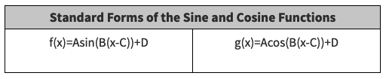
Use Web Link - Desmos Sine and Cosine Applet² below to explore how changing the parameters of a sine and cosine function affects the characteristics of the sound wave.
Use the sliders in the applet to complete Table 1.

¹Web Link - Signal Generator Applet - https://signalgenerator.sciencemusic.org/
²Web Link - Desmos Sine and Cosine Applet - https://www.desmos.com/calculator/aafg5sgys2

Table 1: Relationship between the Parameter and the Graph
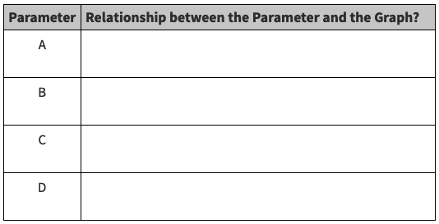
The precise relationship between parameter B and the graph is not obvious. B represents the factor by which the sine or cosine curve is stretched along the x-axis. When B = 1, the period (in this case, the time it takes to complete one cycle of the graph) of the sine or cosine curve is 2? In general, for a single sine or cosine function,

period=2B

Part II: Modeling a Sound Wave
Write a function that models the following sound wave. Remember: period=2B
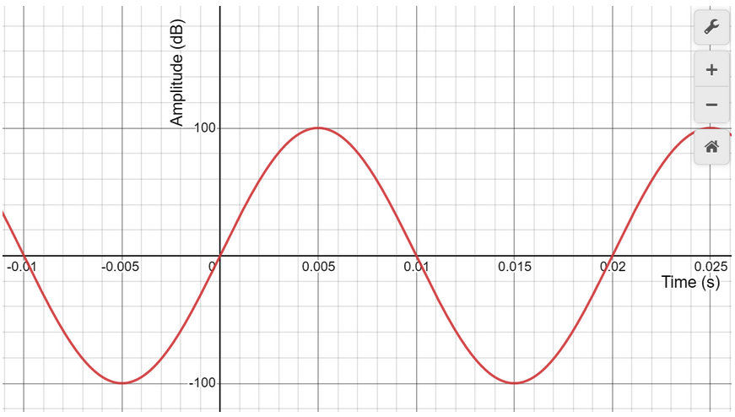
Function: _________________________________________________________________

Part III: Constructing Canceling/Dampening Waves
When two (or more) sounds are played together, their resulting sound wave can be modeled using the combination of the two individual sound waves. One way to dampen or cancel a sound wave is by introducing a new sound wave that, when combined with the original, will have an amplitude of 0. This is called destructive interference. Use Web Link - Desmos Canceling/Dampening Waves Applet³ below to explore how combining functions can help you cancel sound.
What has to be true about the relationship between the graphs of f(x) and g(x) for their combination (f(x) +g(x)) to have an amplitude of 0 (flat line)? Why is this true?

Part IV: Now you Try
Consider the sound wave from Part II.
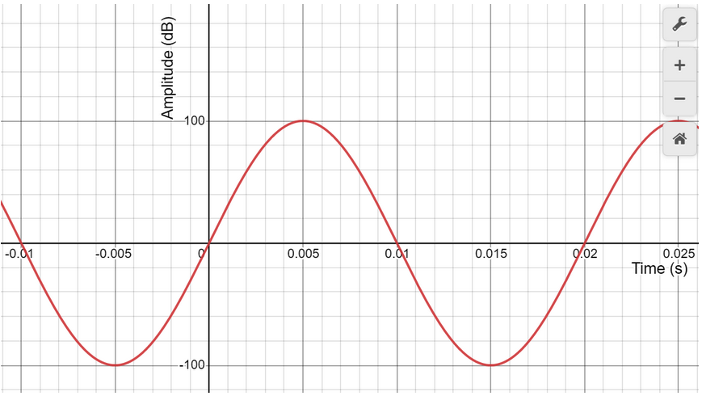
- On the same graph, sketch a sound wave that would cancel the sound wave from Part II.
- Write a function that represents the curve you sketched.
Now use this process to build your prototype. What information will you need to build a function that will cancel the sound you selected? Once you have what you need, use Desmos Web Link - Desmos Calculator⁴ to show an example of how your noise-canceling device will work.
³Web Link - Desmos Canceling/Dampening Waves Applet - https://www.desmos.com/calculator/b2p1hnoat7
⁴Web Link - Desmos Calculator - https://www.desmos.com/calculator

