
A geometric transformation is a function that generates a new figure (called an image) by changing the points in a given figure (preimage). That is, the points that make up the preimage are inputs of the function and the points that make up the image are outputs.

Use the following interactive applets to review common examples of rigid and non-rigid transformations.
- Translations, Rotations, Reflections, and Dilations - Note: This applet refers to a dilation as an “enlargement.”

Using Geometric Transformations to Describe the Features of Your Prototype
Using the language of geometric transformations can help you effectively explain how your product works and describe the different forms it can take.

To describe a transformation, you need to include: (1) the type of transformation, (2) the point or line of reference, and (3) a description of how the figure is being transformed. If you need to use more than one transformation, provide this information for each transformation in the order it was performed.

Example 1: This image shows a transformation that maps rectangle ABCD onto rectangle A’B’C’D’.
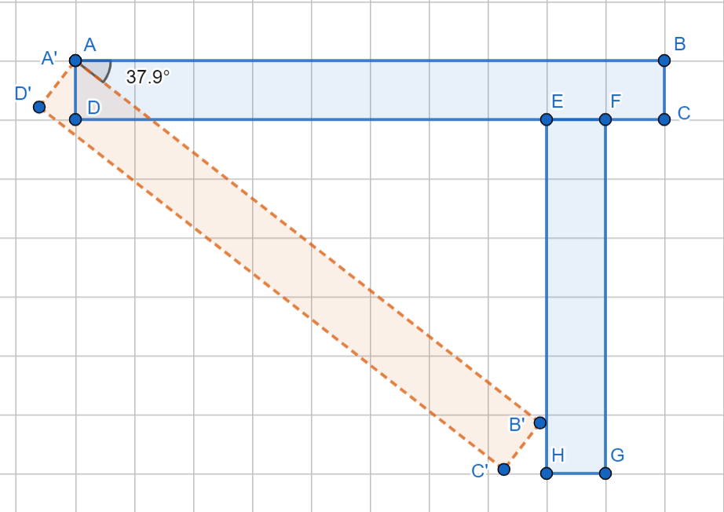
- Describe the transformation. Use GeoGebra link to check your answer. Note: The apostrophe (‘) symbol is used to indicate that a point is an image of another point with the same name. For example A’ is the image of A.
- How could this transformation be used in an actual physical product? Use your imagination.

Example 2: This image shows a blue figure that can be mapped onto the orange figure using a sequence of transformations.
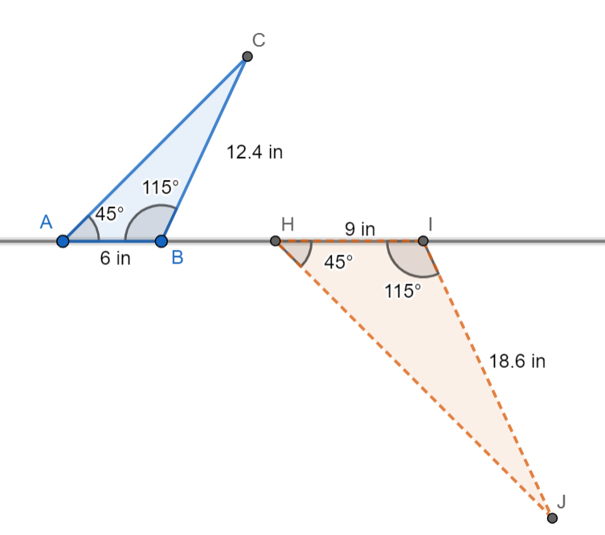

- Describe the sequence of transformations that map △ABC onto △HIJ. Use GeoGebra link to check your answer. Note: In this example, you will need to identify the pairs of corresponding points.
- How could this transformation be used in an actual physical product? Use your imagination.

Example 3: In the following image, the blue quadrilateral can be mapped onto the orange quadrilateral using a dilation.

- Use GeoGebra link to find the center of dilation and scale factor that maps quadrilateral ABCD onto FGHK.
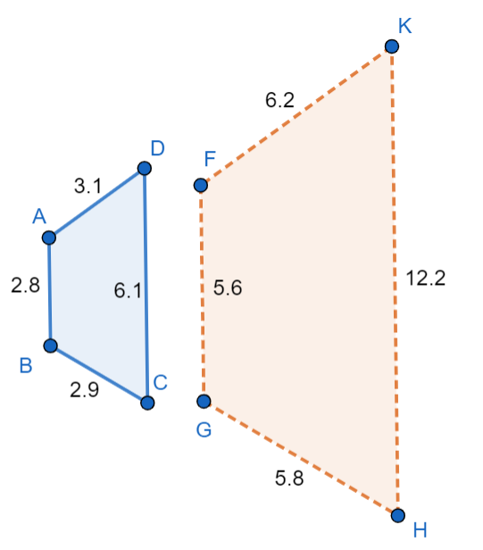
Scale Factor:

Center of Dilation:

Note: To identify the center of dilation, describe how to find the point using the given figures.

- How could this transformation be used in an actual physical product? Use your imagination.

Your Turn
Use GeoGebra or Desmos to sketch your structure. Be sure to include at least two forms of your structure and a description of the transformations needed to use one form of the structure to create the other.

