### 

Given a constant speed, you can use ratios and linear functions to predict how long it will take them to travel any distance.

**Speed** is a ratio that describes the relationship between the distance an object travels and the amount of time it takes to travel that distance. Complete the following table to identify the distance and time components of each speed.

### 

### 

#### **Using Speed to Predict Travel Times**

#### When working with ratios, it is important to pay careful attention to units.

### **Example 1: Speed Represented as *Distance per Time***

Diyah wants to predict how long it will take her to travel different distances when traveling at a constant speed of 40 miles per hour. She builds the following table to look for patterns.

1. Fill in the missing values in the following table.

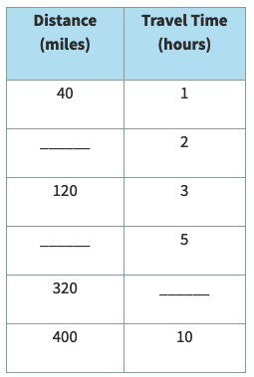

1. Describe a general pattern that you could use to build one row in the table using a previous row in the table.
2. Describe a pattern that you could use to make the quantities in the left column of the table equivalent to the quantities in the right column of the table.
3. Write a function that uses Diyah’s **distance (x)** to calculate her **travel time (y)** for any **speed (v)** she travels.
4. **Use your function** to predict how long it will take Diyah to travel 5 miles if she travels at an average speed of 25 miles per hour.

### **Example 2: Speed Represented as *Time per Distance***

Diyah wants to know how her function would change if she used different units for speed. She builds the following table based on a constant speed 15 minutes per mile.

1. Fill in the missing values in the table.

### 

1. Describe a pattern that you could use to get from one row in the table to another row in the table. How does each number relate to Diyah’s situation?
2. Describe a pattern that you could use to get from the left column in the table to the right column in the table. How does each number relate to Diyah’s situation?
3. Write a function that uses Diyah’s **distance (x)** to calculate her **travel time (y)** for any **speed (v)** she travels. Be sure to define your variables.
4. **Use your function** to predict how long it will take Diyah to travel 9 miles if she travels at an average speed of 15 minutes per mile.

**Building a Function from a Table**

#### The following table represents Constance’s distance and time during a run. To keep track of how long it takes her to exercise in total, she includes her 20 minutes of stretching in her total time.

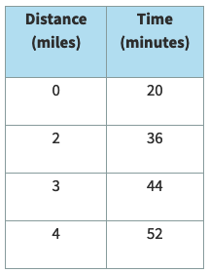

1. How can you tell that this table represents a linear function?
2. Write a function that uses Constance’s **distance (x)** to calculate her **travel time (y)**. Assume her speed is constant.
3. Use your function to predict how long Candace will be exercising if she runs 9 miles.