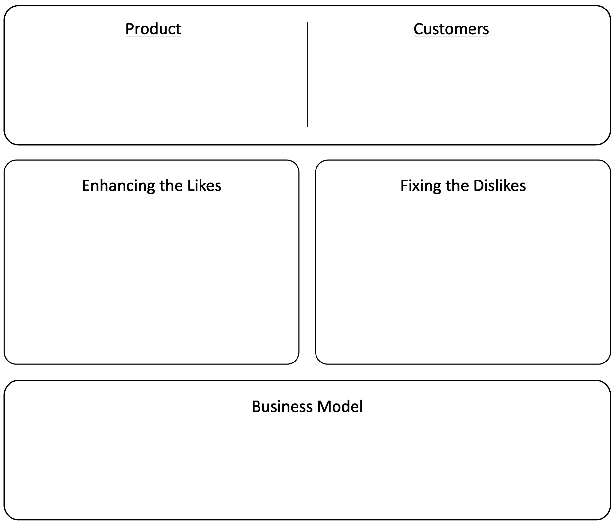

Entrepreneurs look for ways to create value for their customers. Creating value means making a customer’s situation or job better. This can be done by enhancing something that they like about their situation (likes) or fixing something that they don’t like about their situation (dislikes). Use the chart below to describe your product, your customers, and how your product creates value for them.
Once you’ve developed your product idea, you need to begin developing your business around your product. Use the Business Model section to describe how your business will make money.

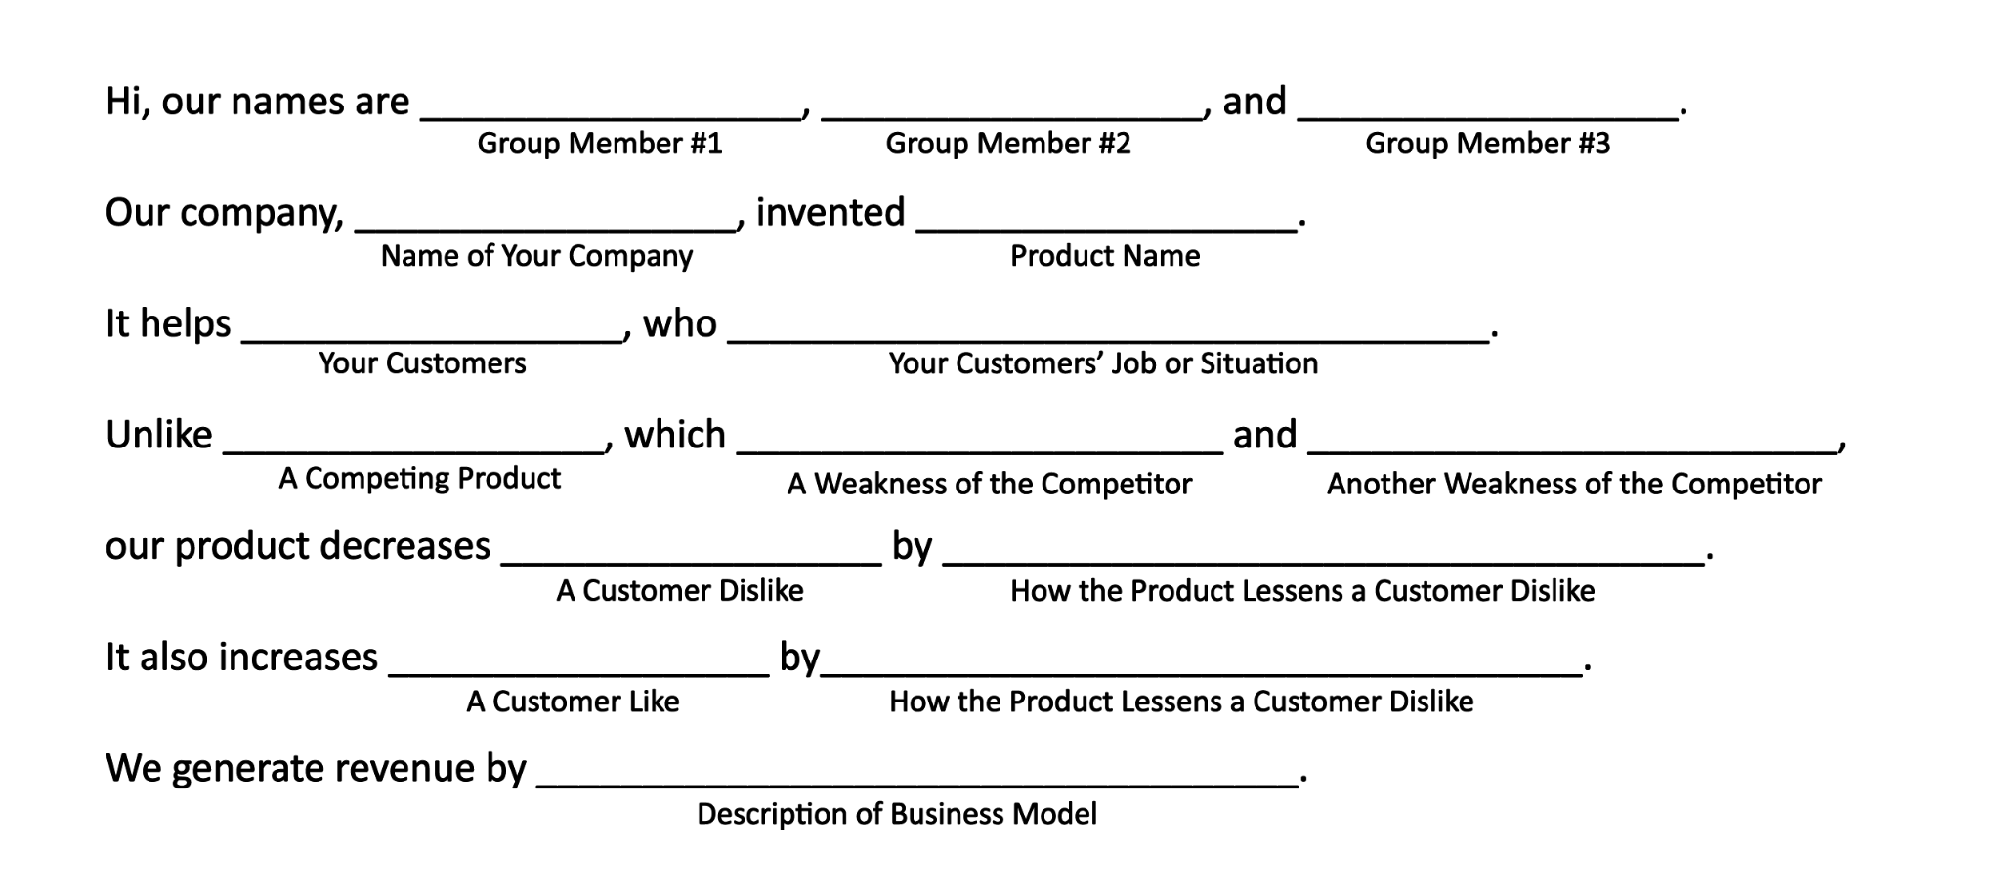
Practicing Your Elevator Pitch
Entrepreneurs must be able to quickly and convincingly explain their product to investors. This is often called an elevator pitch because they should be able to fully explain their product during an elevator ride. Below, you will find a template for a basic elevator pitch that can help you think more about the decisions you made in the diagram on the first page of the Key Business Proposition and whether or not they make sense. Fill in the blanks and practice saying your elevator pitch out loud several times to make sure you and your team members are on the same page about your product and your business.

