Building Weighted Networks

Traditionally, we have come to think about graphs as a visual representation of a function. In the context of networks however, they represent something different. A graph is a mathematical structure that is composed of nodes and edges. Nodes (also called vertices) are the fundamental units of a graph and they are connected by edges.

For example, the town of Connectville can be represented using the graph below. The nodes of the graph represent important buildings (hospital, school, bank, etc) that are in the town and the edges represent possible roads that the town is considering building.
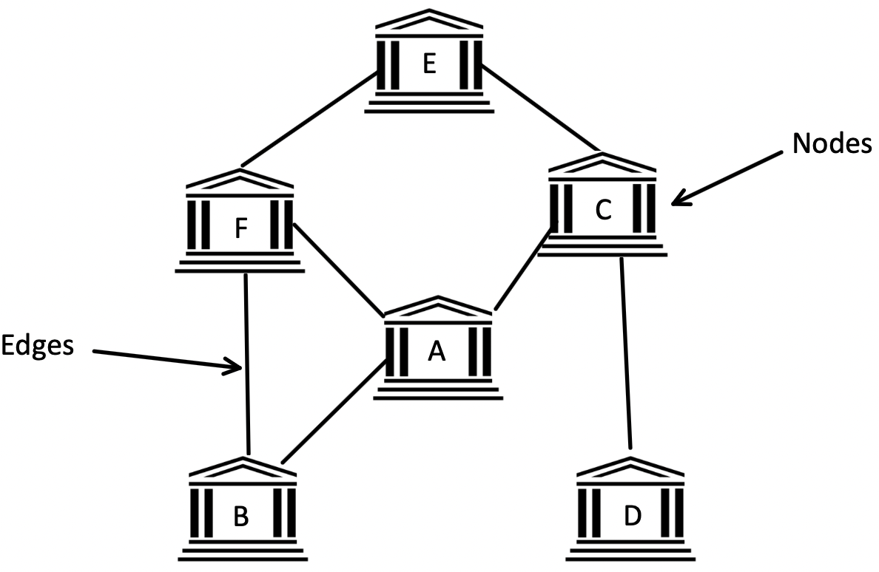

- Why might a connection between building D and building A not be possible?

- If Connectville builds these roads, describe how someone would get from building B to building E?

- How would someone get from building F to building D?

A graph is called connected when it is possible to get from every node to every other node in the graph. Another name for a connected graph is a network.

- As pictured, would the graph of Connectville be considered a network? Why or why not?

A weighted network is a special type of graph in which a numerical value is assigned to each edge and is based on some underlying characteristic of that edge. Weights can help us make decisions about the network like which road to build first or which path to take to get from one building to another. In the graph below, each edge is labeled with a number that represents the length of each road in miles. It is important to note that the weight of an edge does not have to correspond to its length.
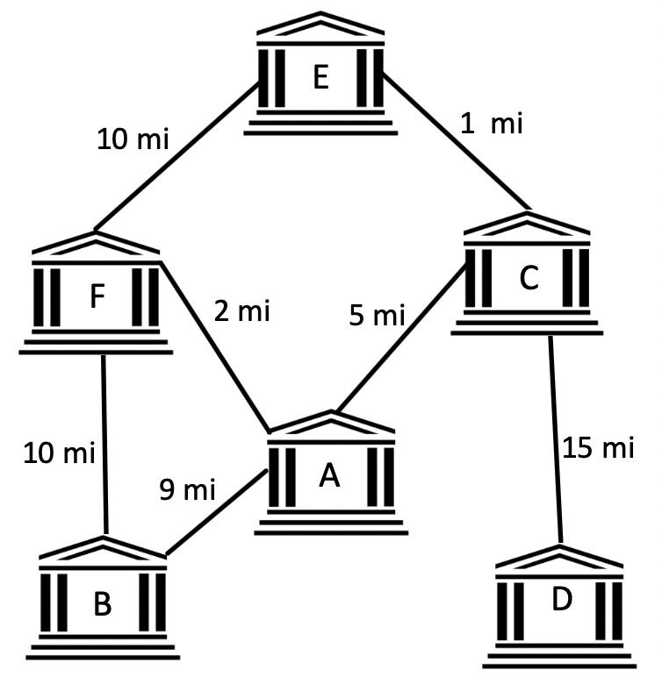

When considering what to use as the weights for your weighted network, it can be problematic to only take into account one variable.

- Why would it be problematic for the town to only consider distance when calculating edge weights?

The table below provides information on two other variables the town wants to consider. The second column gives information on how many citizens would be displaced if each road is built. The third column gives the percentage of customers that local businesses in the town might lose if that particular road is built. In the table, the edge A-C refers to the edge that connects building A and building C.

Edge | Number of Citizens Displaced | Percentage of Customers Lost | Distance in Miles (fill this in using the graph)
A-C | 8 | 13% | 5
E-F | 19 | 10%
C-E | 12 | 11%
B-F | 10 | 20%
A-F | 23 | 5%
A-B | 15 | 12%
C-D | 21 | 18%

- How could you combine the three variables (distance, displaced citizens, customer loss) into a single weight? Provide the calculations for edges E-F and A-C. Note: There is not a single correct answer to this question. Your goal is to combine the variables into a single weight that you believe best represents the relationship between the two buildings.

- If the new weights were calculated for every edge, how could this new weighted network be useful to the city?

- Your Turn: What variables are important to your solution? Start brainstorming how you could combine those variables.

